Form PM - 01

Project Management
Plan/Charter

By: Muhammad osama

PROJECT MANAGEMENT PLAN TEMPLATE

Release #: 3rd
Project Manager: Masood Arif
Approvals:
Masood Arif
Project Manager Prime Contractor Manager - (if applicable)
School Library osama & team
State Organization Management User Management

Oversight Manager - (if applicable)
Accounts
Department of Finance Other:
1. Project Summary
Information in the project summary areas was started during the project concept phase and should be included here.
Project Name: | Library Management System | Start Date: | 25/3/2021

State Organization:: | PAF-KIET | Submitted by: | Muhammad osama

Prime Contractor: | Dr. Umema hani | Date Awarded: | 2/March/2007

Current Stage of Project: | Software Development Life Cycle (SDLC) – SPIRAL Model

Project is On Schedule: | Yes:  No:  Details: the project build was based on the schedule of completion of 4 months’ duration in the 25% average on per month. | Project is within Budget: | Yes:  No:  Comments: The project has 6 lakhs budget.

Please answer the following questions by marking “Yes” or “No” and provide a brief response as appropriate | Yes | No
Is this an updated Project Plan? If so, reason for Update: Yes

Budget for project by fiscal year and is project funded? If so, for what amount(s) and period(s):  Budget Amount: Year:2021 Funded?  Budget Amount: Year: 2022 Funded?  Budget Amount: Year: 2023 Funded?  Total Budget: | yes | no  no
Project Summary - Continued
Points of Contact
This should be the list of individuals that will be involved with the project during the execution phase.
Position | Name/Organization | Phone | E-mail
Project Manager | Masood arif | 7898181480 | Masood@gmail.com
Senior Management Sponsor | Sumair ul haq | 47348734 | sumairk198@gamil.com
Senior Technical Sponsor | Hassan Habib Khan | 938939389 | Hassanhabib356@hotmail.com
Procurement Contact | Initial
Customers: | Students, Member , Faculty
Other Stakeholders (Top 3):

Prime Contractor Information
Company: School Library
Position | Name | Phone | E-mail
Project Manager | Masood arif | 09393984908 | Masood@gmail.com
Senior Technical Sponsor | Hassan Habib | 08768734838 | Hassan@hotmail.com
Contracts Contact | Muhammad Osama / M. Hassaan | 982818738743 | -
2. Project Charter
Business Problem.
All projects start with a business problem/issue to solve.

Library Management System is a term for computer-based system that manage the catalogue of a library. The main purpose of this system is to manage library daily operation efficiently. ... It is also created to ensure that the library items are stored properly in order to maintain their security The library management system is a software to manage manual functions of a library. The software helps to manage the entire library operations from maintaining book records to issue a book.

Statement of Work (Goal).
The statement should be short and to the point. It should not contain language or terminology that might not be understood.

This product aims to replace the current manual system with the automated solution. The main system will comprise of 6 major sub-systems or Modules the integration of theses sub-system will form the main system. All the sub-systems will be tightly integrated so as to give unanimity to user. The current client setup does not have any automation. Therefore, every department and the section will be developed from scratch as all departments are currently working manually. In this document we are covering “Human resource and payroll System” only.
- Login
- User Authorization
- Book Transaction Module
- Member Maintenance Module
- Publisher Maintenance Module
- Report Module

2. Project Charter, continued
Project Objectives:
Provide a brief, concise list of what the project is to accomplish.
The primary function of our library is to implement, enrich and support the educational program School. The library provides a wide range of materials at various levels of sophistication with a diversity of appeal and different points of view.. The main divisions of the system are:
- Authentication user to check Member authentication of l ibrary system
- Library Management and Book stocks will be maintained (CRUD)
- Book transaction module is to manage the receiver’s data accordingly
- Publisher maintenance Module to arrange the books sections
- Member maintenance Module faculty/Students Record
- Report Module to manage the payment report
This Project is specifically focused over Module 2 and 5

This Project is specifically focused over Module 1 and 5

Success Factors:
List factors that will be used to determine the success of the project.
1. Complete deployment of all 4 modules
2. Smooth integration between all systems
3. effacingly error resolve
4. Everything is going according to the plan
Project Dependencies/Constraints:
Project completion is expected in less than 3.5 months duration
All requirements will be 100% available during requirement phase
Maximum team strength 5

3. Project Tradeoff Matrix & Status Summary
Schedule/Time | Scope/Modules | Resources/Effort/People
CONSTRAINED | CONSTRAINED / ACCEPTED | CONSTRAINED / Need to be IMPROVED  (Cocomo effort = 10 not acceptable our constraint is max 5 members in 3.5 months)
Identify variable to be CONSTRAINED, IMPROVED, ACCEPTED
Comments:

Accepted

+/- Status (Review and Progress Meeting)

 | Team | Tech | Schedule | Cost | Comment
RM 1 | Requirement SRS and Modeling | -/+ | -/+ | -/+ | SRS Submission
RM 2 | PMP | Chap 7 and 18 not complete and chap 1/6 complete | Next week (29/3) meeting  Ch 1 and 2 done - /+ | -/+ | PMP Submission
RM 3 | Modeling | -/+ | -/+ | -/+ | Done already in SRS
RM 4 | Coding and Testing | -/+ | -/+ | -/+ | Testing Report Submission
RM 4 | Demo / Deployment | -/+ | -/+ | -/+ | Final Project Report Submission
Discuss:
Legend
+ = Ahead of Schedule
- = Behind Schedule
/ = On Schedule
4. Project Organization
Provide an organization chart that defines the person responsible for at least the following functions: project manager, development manager, quality assurance, and configuration management.
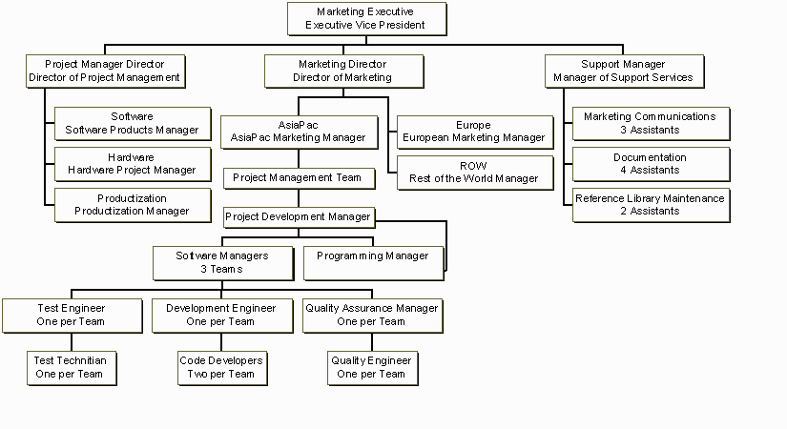
RE team
5 SOFTWARE ENGINEERS
Co-PM or Team lead/ GL
Library Management
Masood Arif / Admin / Tester
Team Librarain

SDLC Process Model:

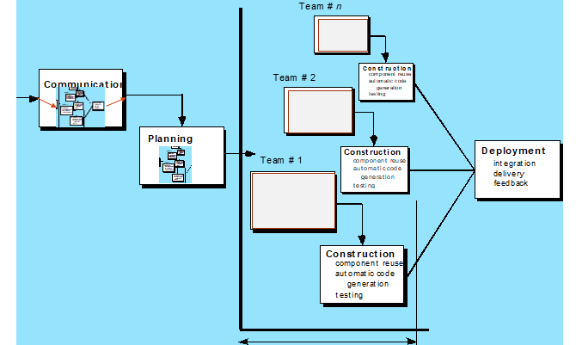
5

5. Activity List (Work Breakdown Structure)

Provide an activity list (work breakdown structure) that describes each task required by the project, with a reference to the statement of work. For large projects, work packages might be included that describe in detail how specific tasks will be completed by specific project teams. These work packages describe required schedule, identify requirements to be completed and describe specific work to be performed
- First Estimating FP then from it E and S.

Software Size Estimation using Function Point Method
- Detail of 5 Transaction Types, at most 5 under each category
 | Write down exact Screen or Forms names, or Tables, or Reports name for each count value.
EI | 1. Login/User Authorization 2. Book transaction 3. Member Maintenance 4 Publisher Maintenance 5. Report
EO | 1. Users table 2. Book Record table 3. Member table 4 publisher table 5. Report table
EQ | 1. Search User 2. Book search 3. Member search 4 Search publisher 5. Search report
ILF | 1. Login/User Authorization 2.Library Management 3. Member 4 publisher 5.Report
ELF | 1. User Authorization Details - 2. Book transaction details - 3. Member Maintenance details - 4. Publisher Maintenance details - 5. __ Report __ details _-_____

- Unadjusted Function Point Value calculation
Definition of Complexities: Your Transactions which are derived from only from 1 Table are to be categorized as Low and if they are derive from 2 tables they can be categorized in Mid-level complexity, and in case of >= 3 they will be placed under High level of complexity.

 | Count for screens of Low level complexity (C) | Multiplier  Low level complexity (M) | V1 = C * M | Count for screens of Mid-level complexity (C) | Multiplier  Mid-level complexity (M) | V2 = C * M | Count for screens of High-level complexity (C) | Multiplier  High-level complexity (M) | V3 = C * M | Category wise sum  V1+V2+V3
EI | 3 | 3 | 9 | 1 | 4 | 4 | 1 | 6 | 6 | 19
EO | 3 | 4 | 12 | 1 | 5 | 5 | 1 | 7 | 7 | 24
EQ | 3 | 3 | 9 | 1 | 7 | 7 | 1 | 6 | 6 | 22
ILF | 3 | 7 | 21 | 1 | 0 | 0 | 1 | 15 | 15 | 36
ELF | 0 | 5 | 0 | 0 | 7 | 7 | 0 | 10 | 10 | 17
Unadjusted Function Point Value = |  |  |  |  |  |  |  |  |  | 118

C) Value Adjustment Factor (VAF) calculation
Note: Calculate Value Adjustment Factor, where any 5 "General System Characteristics (GSC) must have a value above 2. Also show respect Quality Characteristic mapping of these 5 factors.
 | Quality Characteristic | Weight  (0-5) |  | Quality Characteristic | Weight  (0-5)
 |  | 3 |  |  | 3
 |  | 2 |  |  | 2
 |  | 1 |  |  | 4
 |  | 4 |  |  | 1
 |  | 5 |  |  | 3
 |  | 0 |  |  | 2
 |  | 1 |  |  | 0
Value Adjustment Factor (VAF) = 31

D) Technology Complexity Factor calculation

TCF = 0.65 + (VAF * 0.01)
= 0.65 +(31*0.01)
= 0.96

E) Adjusted Function Point Value (AFPV) or Function Point Value (FP) Calculation

AFPV = _ Unadjusted Function Point * TCF
= 118 * 0.96
= 113.28

F) Conversion of AFPV in to LOC Size metric

the number of LOCs per FP for C# language 54 and check other languages from https://www.qsm.com/resources/function-point-languages-table, ASP 51 and VB.net 52

Project Size in LOC = AFPV * LOC/FP
Project Size in LOC = 113.28 * 54 = 6117.12 LOC
G) Software Size: 6117.12
Software Size for COCOMO: 9.779 KLOC
Software Type: Business/ Utility/Embedded
Model Mode: Cocomo I – Basic – ORGANIC (0 – 50 KLOC) / Semi detached/Embedded
- Effort Estimation: Equation
2.4 * 9.779 ^ 1.05 = 26.3039
- Schedule Estimation: Equation
2.5 * E ^ 0.4 months = S
S= 2.5 * 26.3039^0.4
S = 9.2458
- Productivity Estimation: Equation
Loc/E = 9779/26.3039 = 371.7699

- Average Loading Estimation: Equation
E/S = 26.3039 / 9.2458
2.8449
- Average Salary of Technical Staff (AS): Equation
Assume = 50,000 RS
- Cost for Salary (Cs): Equation
E * Avg salary = 26.3039 * 50,000
1315195
- Budgeted Cost of Project (Cb): Equation
Cs + Cs * X% = Cb
Cb = 1315195+ (2% of11315195)
Cb =1315195+26303.9
Cb = 1341498.9
- Calculate the phase-wise percentage distribution wise E and S values as given in detailed COCOMO detailed model.

H) Distribution of Effort and Schedule among Different phases of SDLC
E = ___26.3039__________________________
S = ______9.458________________________
Plan and Requirement |  | Modeling / System Design & Detailed Design |  | Module Coding and Unit Testing |  | Integration & Deployment
0.06 * E = | 0.10 * S = | (0.16+0.26) * E = | (0.19+0.24) S = | 0.42 * E = | 0.39 * S = | 0.16 * E = | 0.18 * S =
1.5782 | 0.9245 | 11.0476 | 1.9967 | 11.0476 | 3.6058 | 4.2086 | 1.6642

- Now adding percentage distribution as given in detailed COCOMO model in the WBS phase-wise.
1.
HRPRL Development
100% Effort
100% Schedule
1.2
Project Planning
0.03% E
0.05% S

1.2.1
Initiate Plan

1.2.2
Develop Plan

1.2.3
Monitor progress and Update Plan (PMP)

1.5
Integration and Deployment
0.16% E
0.18% S

1.5.1
Integrate System

1.5.2
Test System

1.5.3
Delivery and Installation

1.5.4
Accept Installed System
(Final Project Report & Demo)
1.1
Inception/ RE
0.03% E
0.05% S

1.1.1
Initial Feasibility

1.1.2
Cost Benefit Analysis

1.1.3
System requirement Analysis SRS

M1
1.1.3.1
0.006 % E

M5
1.1.3.5

0.006 % E

M1
1.4.4.1
0.43/5 % E
0.6/5 % S

M5
1.4.4.5
0.43/5 % E
0.6/5 % S

M1
1.2.3.1
0.006 % E

M5
1.2.3.5

0.006 % E

M1
1.3.4.1
0.42/5 % E
0.43/5 % S

M5
1.3.4.5
0.42/5 % E
0.43/5 % S

By Team Lead
0.16% E
0.18% S

1.3
Elaboration/Modeling/ System Analysis and Design
0.42% E
0.43% S

1.3.1
System Architecture Design

1.3.2
Software Requirement Analysis

1.3.3
Software Architecture Design

1.3.4
Software Detail Design (SDD) – (Already DONE with SRS in OOAD)

1.4
Construction/Coding/Testing
0.43% E
0.39% S

1.4.1
Develop Software Components

1.4.2
Unit Test Components

1.4.3
Integrate Components

1.4.4
Test Software Modules (Test Report)

- Now convert WBS contents in a Tabular format in order to make a GANTT CHART.

Activity # | Activity Name | Activity Name Description | # of Days | Start Date | Dependency on previous tasks | Milestone
1.1 | RE | Requirement Engineering | 28 | 24/1/2021 | none | 21/2/2021
1.1.1 | Initial Feasibility |  | 3 | 24/1/2021 | None | 27/1/2021
1.1.2 | Cost Benefit Analysis | Analysis of cost | 3 | 27/1/2021 | None | 30/1/2021
1.1.3 | System requirement Analysis SRS | Gather info (SRS) | 6 | 30/1/2021 | None | 5/2/2021
1.1.3.1 | System requirement Analysis SRS for Module 1 | Gather info for module 1 | 3 | 5/2/2021 | None | 8/2/2021
1.1.3.2 | System requirement Analysis SRS for Module 2 | Gather info for module 2 | 3 | 8/2/2021 | None | 11/2/2021
1.1.3.3 | System requirement Analysis SRS for Module 3 | Gather info for module 3 | 3 | 11/2/2021 | None | 14/2/2021
1.1.3.4 | System requirement Analysis SRS for Module 4 | Gather info for module 4 | 3 | 14/2/2021 | None | 17/2/2021
1.1.3.5 | System requirement Analysis SRS for Module 5 | Gather info for module 5 | 3 | 17/2/2021 | None | 21/2/2021
1.2 | Project Planning | Project Management Planning | 16 | 15/3/2021 | 1.1 | 5/4/2021
1.2.1 | Develop plan | Development of project plane | 1 | 15/3/2021 | RE | 16/3/2021
1.2.2 | Implement plan | Implementation of project plane | 1 | 16/3/2021 | RE | 17/3/2021
1.2.3 | Monitor Progress | Take review on each phase | 1 | 17/3/2021 | RE | 18/3/2021
1.2.3.1 | Monitor Progress for module 1 | Planning and monitor progress for module 1 | 1 | 18/3/2021 | RE | 19/3/2021
1.2.3.2 | Monitor Progress for module 2 | Planning and monitor progress for module 2 | 1 | 19/3/2021 | RE | 20/3/2021
1.2.3.3 | Monitor Progress for module 3 | Planning and monitor progress for module 3 | 1 | 20/3/2021 | RE | 21/3/2021
1.2.3.4 | Monitor Progress for module 4 | Planning and monitor progress for module 4 | 1 | 21/3/2021 | RE | 22/3/2021
1.2.3.5 | Monitor Progress for module 5 | Planning and monitor progress for module 5 | 1 | 22/3/2021 | RE | 23/3/2021
1.3 | System architecture design | Develop Architecture System Design | 1 | 23/3/2021 | planning | 24/3/2021
1.3.1 | System requirement | Analysis | 1 | 24/3/2021 | Planning | 25/3/2021
1.3.2 | Software architecture design | Implement Design | 1 | 25/3/2021 | Planning | 26/3/2021
1.3.3 | System detail design | Develop System detail design | 1 | 26/3/2021 | Planning | 27/3/2021
1.4 | Construct, Coding and Testing | Implementation of software | 1 | 27/3/2021 | 1.2 | 28/3/2021
1.4.1 | Develop software Components | Implementation of software | 1 | 28/3/2021 | Design | 29/3/2021
1.4.2 | Unit test components | Implementation of software | 1 | 29/3/2021 | Design | 30/3/2021
1.4.3 | Integrate components | Test for every Module | 1 | 30/3/2021 | Design | 31/3/2021
1.4.4 | Test software Module | Test at end | 1 | 31/3/2021 | Design | 01/4/2021
1.5 | Integrate and development | Development of a project | 1 | 01/4/2021 | Construction /coding/ testing | 02/4/2021
1.5.1 | Integrate system | Combine module | 1 | 02/4/2021 | Construction /coding/ testing | 03/4/2021
1.5.2 | Test System | Test all project | 1 | 03/3/2021 | Construction /coding/ testing | 04/3/2021
1.5.3 | Delivery and installation | Installation / Final test after deploy a project | 1 | 4/4/2021 | Construction/  coding/ testing | 5/4/2021
6. Work Product Identification
Provide a list of all deliverables required by the project, the date due and the person responsible for the deliverable. Pick Last activities from each phase they are deliverables.

Deliverable Name | Due Date | Date Delivered | Point of Contact
SRS by Member 1 | 21/2/2021 | 22/2/2021 | 9760
SRS by Member 2 | 21/2/2021 | 21/2/2021 | 9910
SRS by Member 3 | 21/2/2021 | 21/2/2021 | 9763
SRS by Member 4 | 21/2/2021 | 21/2/2021 | 9646
SRS by Member 5 | 21/2/2021 | 21/2/2021 | 9779
PMP by Member 1 | 5/4/2021 | 5/4/2021 | 9760
PMP by Member 2 | 5/4/2021 | 5/4/2021 | 9910
PMP by Member 3 | 5/4/2021 | 5/4/2021 | 9763
PMP by Member 4 | 5/4/2021 | 6/4/2021 | 9646
PMP by Member 5 | 5/4/2021 | 5/4/2021 | 9779
7. SCHEDULE
Provide the project schedule, using a Gantt chart. The schedule must include milestones, task dependencies, task duration, work product delivery dates, quality milestones (reviews/audits/inspections), configuration management milestones, and action items (with deadlines and responsibilities).
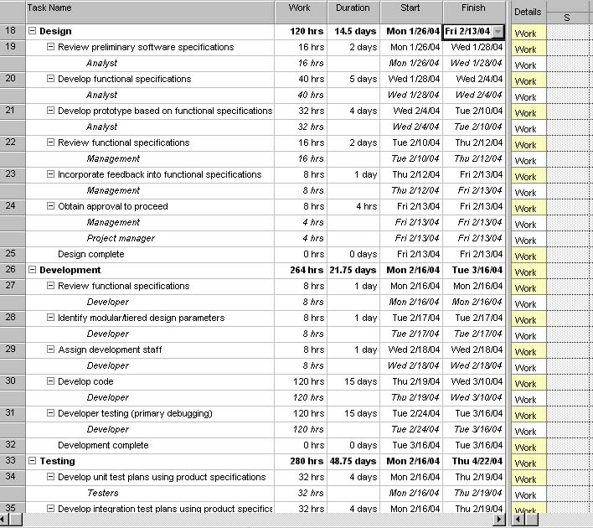

Work Packages, Tasks & Activities |  | Week
 |  | 1 | 2 | 3 | 4 | 5 | 6 | 7 | 8 | 9 | 10 | 11 | 12
Concept Exploration | Internal Case Study
Concept Exploration | Communicate with CRM
Initial Project Plan | SPMP Pass #1
Initial Project Plan | Review by CRM
Initial Project Plan | SPMP Pass #2
Travel & Orientation | Meeting with CRM Representatives
Travel & Orientation | Meeting with 26 programmers
Travel & Orientation | Recruiting into Organizational Chart
Travel & Orientation | OOP Training
Initial SRS | SRS Pass #1
Initial SRS | Prototype 1 (Screens)
Initial SRS | SRS Review by Team
Final SPMP | Pass #3
Final SRS | SRS Review as per SPMP
Final SRS | SRS Submission to CRM
Design | High level Design
Design | High Level Review
Design | Prototype 2
Design | Detail Level Design
Design | Detail Level Review
Design | Prototype 3
System Construction | Source Code & Executable Program
System Construction | Review by CRM
System Verification & Validation | Testing Summary Report
System Verification & Validation | Review by CRM
System Verification & Validation | Customer Acceptance Feedback
System Delivery | System Delivery & Maintenance
8. Estimated Cost at Completion
Provide an estimated cost at completion, which is an assessment of the total effort at completion of the contract.

Analysis in Hours |  |  |  |  |  |  | Analysis in Dollars
WBS No. | Activity Description | Budget Hours | Actual Hours | Est. to Complete remaining work | Est. @ Complete of project | Variance (+ = More) |  | Budget $ | Actual $ | Est. to Complete | Est. @ Complete | Variance (+ = More)
 |  |  |  | A+ @ | @ = B-A | a-b/a
9. Resource Loading Profiles - Staffing
Provide a staffing plan that shows the number of personnel, by type, that will be required on the project on a monthly basis.

Organization | Liaison- interfaces | Contact Information
Customer: APMM | Masood | 872874287
Subcontractor: None | Hasssa Habib | 87287427887
Software Quality Assurance: CRM | Sumair ul haq | 873873879838
Software Configuration Management: Team 2 | Muhammad Hassaan | 8234874387837
Change Control: Team 2 | M . Osama | 7367439743889

Role | Description | Person
Project Leader | Leads project team; responsible for project deliverables | Masood Arif
Project Management Team/Analysts | Assisting in building SPMP, SRS and prototype, as well as doing the necessary requirement and risk analysis for the project | Hasssa Habib  Sumair ul haq
Project Development Manager | Leads Chinese software developers; responsible for project deliverables | Muhammad Hassaan  M .Osama
Programming Manager | Responsible for the communication between the Management Team and the rest of the software development team; the Programming Manager is also responsible for reallocating the human resources and equipment of the project. | Masood Arif
Software Managers | Responsible for managing the team of 7 people; does the design of the software; after reviewing reports from Test Engineer decides whether code needs to be sent back to Development Engineer for improvement or to be send to Quality Assurance Manager for quality assurance phase | Hassan Habib
Development Engineers | Responsible for designing of software and distributing work among Code Developers | Sumair ul haq
Code Developers | Responsible for writing programming code | Masood Arif
Test Engineer | Responsible for testing and validation process in his/her team; leads Test Technician in the testing process and reports the results of the testing process to the software manager | Masood Arif
Test Technician | Performs the testing and validation procedure; reports found errors to Test Engineer | Muhmmad Osama
Quality Assurance Manager | Responsible for quality assurance; reports to Software Manager and Project Development Manager | Sumair ul haq
Quality Engineer | Performs quality assurance procedure; reports the results to Quality Assurance Manager | Muhammad Hassaan

10. Project Requirements
Provide a detailed listing of project requirements, with references, to the statement of work, work breakdown structure, and specifications.

No. | Requirement | RFP Reference  Not submitted by the client in Adv. | SOW Reference | WBS Task Reference | Specification Reference | Date Completed | Comments/Clarification
1. | 3.1.1 Login | N/A | 1 | 1.1.3.1 | 3.1.1 | 5/4/2021 | Good
2. | 3.1.2 Module 1 CRUDS | N/A | 2 | 1.1.3.2 | 3.1.2 | 5/4/2021 | Improvement
3. | 3.1.3 Module 2 CRUDS | N/A | 3 | 1.1.3.3 | 3.1.3 | 5/4/2021 | Nice
4. | 3.1.4 Module 3 CRUDS | N/A | 4 | 1.1.3.4 | 3.1.4 | 5/4/2021 | Well performed
5. | 3.1.5 Module 4 CRUDS | N/A | 5 | 1.1.3.5 | 3.1.5 | 5/4/2021 | Improvement
6. | 3.1.6 Module 5 CRUDS | N/A | 6 | 1.1.3.6 | 3.1.6 | 5/4/2021 | Good
SOW = Statement of Work
11. Risk Identification
Provide a description of all risks identified for the project. A risk is anything that might detrimentally affect the successful completion of the project if left unaddressed. The contractual, management, and technical risks associated should be identified and assessed as to the probability of the risk occurring, the cost to correct if the risk occurs, the impact of the risk on the project, and the suggested mitigation activities and cost of mitigation.

Risk Worksheet
Last Risk Assessment Date: Prepared by: Hassan Habib Khan

Risk Category/ Event | Loss  Hours | Probability | Risk Hours | Previous Risk Hours | Preventive Measures | Contingency Measures | Comments
Governance Risk | 120 | 0.8 | 48 | - | Our Lawyer will handle all the situation accordingly. | Consult the court or ministers to resolve the issues with government. | CRITICAL
Schedule Risk | 24 | 0.2 | 12 | - | We will have a tight schedule and will make a schedule. According to our schedule project will be completed and deployed before the time. | If our schedule is not as per planned we already made our schedule in a way that we will do the development before time, we will utilize that time as well but if we are too behind schedule our developers have to work overtime. | MEDIUM
Operational Risk | 24-48 | 0.5 | 24 | - | Avoid poor implementations and process problems. | Our managers will be restricted to overcome problems and start implementing new strategies. | LOW
Software Risk | 24 | 0.3 | 24 | - | Hire professionals.  Select the appropriate software for development, stable servers and project management.  We will use the best and most stable servers for every software to avoid future problems. | If we faced this type of emergency we will switch the software technology at once which is currently in use in our organization. We are already using the best servers so we don’t have to worry about that but for the software performance and stability we will use the most talented team of ours to overcome the tie wasted and complete the project fully. | MEDIUM
Staff experience and professionalism. | 24-72 | 0.3 | 48 | - | Our organization hires the junior developers who are under the teams of professional and experienced team leaders. We also have a team of experienced developers which can handle every type of situations and can work under pressure. | If we faced some type problems form our staff we will right away send the project to our experienced developers team or in case they are already stuck in a project we will hire a professional which can team up with our junior developer’s leader and can finish the work according to schedule. | CRITICAL
Natural Hazard risk | - | 0.5 | - | - | Natural Hazards are not something that can be predicted or controlled but humans but we have to be prepared for any type of situation. According to our scheduling we want to complete the project before given time so in this case also we can utilize those leftover days. If the situation is like COVID-19’s hazard our developers will remotely. | If the situation is under control there will be no off. If the situation is critical but will be under control in few days we can either work remotely or take some rest, it all depends on the schedule. But if the situation is critical and we can’t predict when it will be under control our teams will work remotely. | CAN BE CRITICAL
Software Performance and Security Risk | - | 0.4 | - | - | We are using latest and stable technologies but we will still prototype our modules and test the software with huge dummy data and our security team will try to catch the loop holes. Our maintenance team will be ready to handle the panicked situation accordingly. | Software performance is not being compromised form our organization but if we faced this type of situation our maintenance team will right away check the software bugs and our security team will be ready if there something hacking activity detected. | MEDIUM
Poor Management | 48-72 | 0.2 | 48 | - | We will hire professionals for our organization who can face any type of situation and can handle the planning of difficult software. Proper strategies and project planning will be made before starting any project and everyone will act according to the plan. | Our project managers will be asked to revise the project planning and strategies. If they can’t handle the situation we can compromise our management we will right away send project planning to another professional team manager who will work the previous manager to handle the situation with new and better strategies. | MEDIUM
Budget Changes | 48-72 | 0.1 | 60 | - | We will sign the proper legal contract in which every small detail will be mentioned to avoid future difficulties. | However, if the client wants to change the budget we will not leave our client but will act accordingly and we have to compromise on development. Old codes will be refactored, there will be no tough schedule and every situation will be handled by juniors. | LOW

General Risk Analysis Comments:

Risk Items | Risk Management Techniques
Personnel Shortfalls | Staffing with top talent, job matching; team building; morale building; cross training; pre-scheduling key people
Unrealistic schedules and budgets | Detailed, multi source cost and schedule estimation; design to cost; incremental development; software reuse; requirement scrubbing
Developing the wrong software functions | Organizational analysis; mission analysis; ops-concept formulation; user surveys; prototyping; early users' manuals
Developing the wrong user interface | Task analysis; prototyping; scenarios; user characterization (functionality, style, workload)
Gold Plating | Requirement scrubbing; prototyping; cost-benefit analysis; design to cost
Continuing stream of requirement changes | High change threshold; information hiding; incremental development (defer changes to later increments)
Shortfalls in externally furnished components | Benchmarking; inspections; reference checking; compatibility analysis
Shortfalls in externally performed tasks | Reference checking; pre-award audits; award-fee contracts; competitive design or prototyping team building
Real-time performance shortfalls | Simulation; benchmarking; modeling; prototyping; instrumentation; tuning
Straining computer-science capabilities | Technical analysis; cost-benefit analysis; prototyping; reference checking

Risk Management:
1 | Identify the project’s top10 risk items
2 | Present a plan for resolving each risk item
3 | Update list of top risk items, plan, and results monthly
4 | Highlight risk-item status in monthly project reviews.  Compare with previous month’s ranking status
5 | Initiate appropriate corrective actions

12. Configuration Management Plan
Provide a configuration management plan that defines the person responsible for project configuration management, the procedures that will be used, the planned configuration items, planned release dates for configuration items, and resources required to conduct CM.

CM Responsibility
Manager:
Additional Staff for CM:

Procedure Reference:

Configuration Items:. Ensure that CM is implemented throughout the project’s life cycle.
No. | Item | Comments
1. | analysis | prototyping; early users' manuals
2. | risk item | Present a plan for resolving
3. | ranking status | Highlight risk-item status in monthly project reviews

Ensure that project has a repository for storing configuration items and associated CM records. Briefly describe.
responsible for project configuration management, the procedures that will be used, the planned configuration items, planned release dates for configuration items, and resources required

13. Quality Plan
Provide a quality plan that defines the person responsible for project quality assurance, the procedures that will be used and resources required to conduct quality assurance.

QA Responsibility
Manager:
Additional Staff for QA:

Procedure Reference:

Planned Quality Event: Ensure that QA is implemented throughout the project’s life cycle. Dates include QA audits and reviews, design walkthroughs and other project activities that QA staff will participate in.
No. | Item | Comments
1. | Gold Plating | Initiate appropriate corrective actions
2. | Stream | change threshold; information hiding
3. | Shortfalls | cost-benefit analysis; prototyping; reference

Ensure that project has a repository for storing configuration items and associated QA records. Briefly describe.

Ensure that QA audits the baselines and CM activities on a regular basis. Briefly describe

14. Top Five Issues
Provide a list of known issues associated with the project, with proposed or recommended solutions.

Issue Description | Responsible Individual | Open Date | Closure Date | Status
Complete Requirement | Masood Arif |  |  | Held by the complete RE procedure
Development Life Cycle | Hassan habib |  |  | The modeling procedure of defining sustainability
Views | Muhammad Osama |  |  | The user friendly view should be appropriate defining.
Error On uploading | Sumair ul haq |  |  | The hosting file size nor enough
Issue Description | Responsible Individual | Open Date | Closure Date | Status

15. Action Item Status
Maintain a list of action items, including a description of the item, a point of contact a date by which action should be taken and a description of the action taken to close items.

Action Item # | Action Item Description | Responsible Individual | Open Date | Closure Date | Status
 | The Input model | Sumair ul haq |  |  | Resolve
 | Contract | Muhammad Hassan |  |  | Sustain

